Buyer’s Guide to Purchasing 4-H & FFA Livestock
Remember: You must get a bidder number to participate in the auction.

It is important for buyers to know that there are several options of handling the livestock that are purchased during the Show and Sale Auction. Exhibitors will receive the final bid/lb. in the auction no matter the option you choose. Buyers may also join together with a group of people to purchase an animal.

Option 1: Purchase for personal use: A buyer purchasing livestock for personal use will pay the cost of the animal at the sale. There will also be fees associated with slaughtering. The buyer needs to make arrangements with a local processor before the sale.

It is also good to arrange for your own transportation, as our hauling is limited. You will need to notify the sales office of your intentions at the time of settlement. All animals must be removed from the fairgrounds the night of the sale.

All slaughterhouses will require a “cut sheet” with your processing options, be sure to either complete one beforehand or the night of the sale to go with your animal.
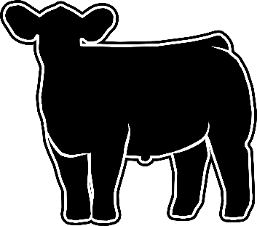
Example 1: 1200lb steer
x $2.15/lb. – winning bid
$2520 - your cost
Slaughter house fees will range from $600-$800 depending on size and processing choices.

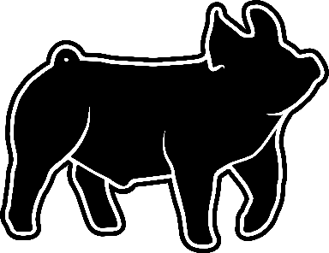

Example 3: 265lb hog
x $4.00/lb. – winning bid
$1060 - your cost
Slaughter house fees will range from $200-$400 depending on size and processing choices.

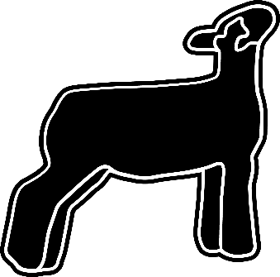
Example 2: 100lb lamb or goat
x $7.50/lb. – winning bid
$750 - your cost
Slaughter house fees will range from $100-$200 depending on size and processing choices.

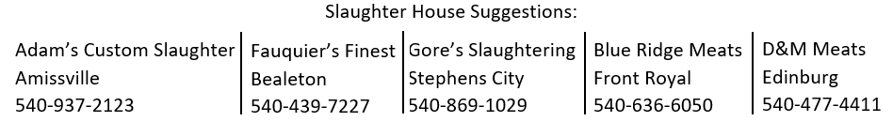

Option 2: Purchase with Resale at the Floor (market) Price: Also known as “flooring” the animal. A buyer may buy livestock during the auction with the intention of reselling the animal at the floor (predetermined market) price that is available just prior to the sale. The buyer will only pay the difference in the auction price and the floor price.

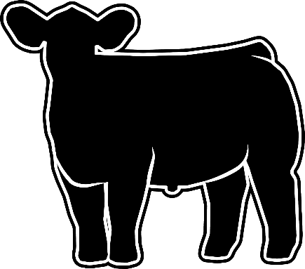
Example 1: 1200lb steer
$2.15/lb. – winning bid
- $1.15/lb. – floor price
$1.00/lb. – your cost
x 1200lb.
$1200 – final cost

$1,200 is the amount the buyer will be billed.

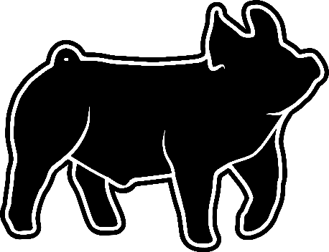

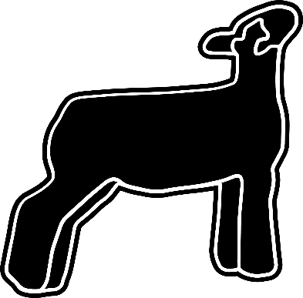
Example 3: 265lb hog
$4.00/lb. – winning bid
- $.60/lb. – floor price
$3.40/lb.
X 265lb.
$901 – final cost
$901 is the amount the buyer will be billed.
Example 2: 100lb lamb or goat
$7.50/lb. – winning bid
- $1.50/lb. – floor price
$6.00/lb. – your cost
x 100lb.
$600 – final cost
$600 is the amount the buyer will be billed.

The Fauquier Livestock Show and Sale is run through the Fauquier Youth Livestock Advisory Council, which is a 501c3 (EIN: 46-3825669). Your contributions to the Show and Sale are therefore tax deductible.

Please do not pay exhibitors directly, all payment should be made to the Fauquier Youth Livestock Advisory Council who will handle disbursement of sale profits to our exhibitors at our end of the year banquet.

